**DHCP Snooping and ARP Inspection Lab Guide**

**GOALS**

1. **L2 Setup**
   1. Using a single L2-Switch (No IP rounting command) setup Vlans 100, 200 & 300
   2. Add two PCs on each Vlan with static IP addresses
   3. Two access ports per Vlan on the L2 Switch
2. **Inter-Vlan**
   1. Use the following Address scheme:
      1. Vlan 100 -> 10.10.100.0/24
      2. Vlan 200 -> 172.16.200.0/24
      3. Vlan 300 -> 192.168.150.0/24
   2. After this step you should have full Intra-Vlan routing connectivity
3. **ROAS**
   1. Configure ROUTER on a ROAS setup and connect to a trunk on the L2 switch
   2. ROUTER should have 3 sub-interfaces to serve as Default gw for each Vlan
   3. Configure the sub interfaces with first usable IP of each range configured on 2.1
   4. Only one cable between the router and the L2 Switch
4. **DHCP Server**
   1. Enable 3 DHCP scopes on Router. One for each Vlan exclude the first 20 IPs of each range
   2. Make the first usable IP of each range the default gw
   3. Configure all hosts to use DHCP addresses instead of static
   4. After this step you should have full inter-Vlan routing connectivity
   5. Ping hosts on other Vlans
   6. Test by Pinging hosts on other Vlans and creating a loopback with IP 8.8.8.8 on Router and ping it from any host
5. **DCHP Snooping** 
   1. Enable DHCP snooping on the L2-switch on Vlans 100, 200 & 300
   2. Release and renew all host’s IPs
   3. Did they receive IP addresses from the DHCP? (Hint: one of the interfaces have to be trusted)
   4. Check the IP DHCP snooping binding table. You need a binding table to move to the next bullet
6. **ARP Inspection**
   1. Enable ARP inspection on the L2 switch on Vlans 100, 200 & 300
   2. Can you ping the Default Gateways?
   3. Can you ping 8.8.8.8?
   4. Check the IP ARP inspection statistics. Do you have any dropped packets? Why?
   5. If yes, Hint, one of the interfaces have to be trusted
7. **Extra Stuff**
   1. Setup one more host per Vlan, and have it use static IP address.
   2. Can this host ping anything in the network?
   3. If not? hint, check your ARP filtering.

Topology:

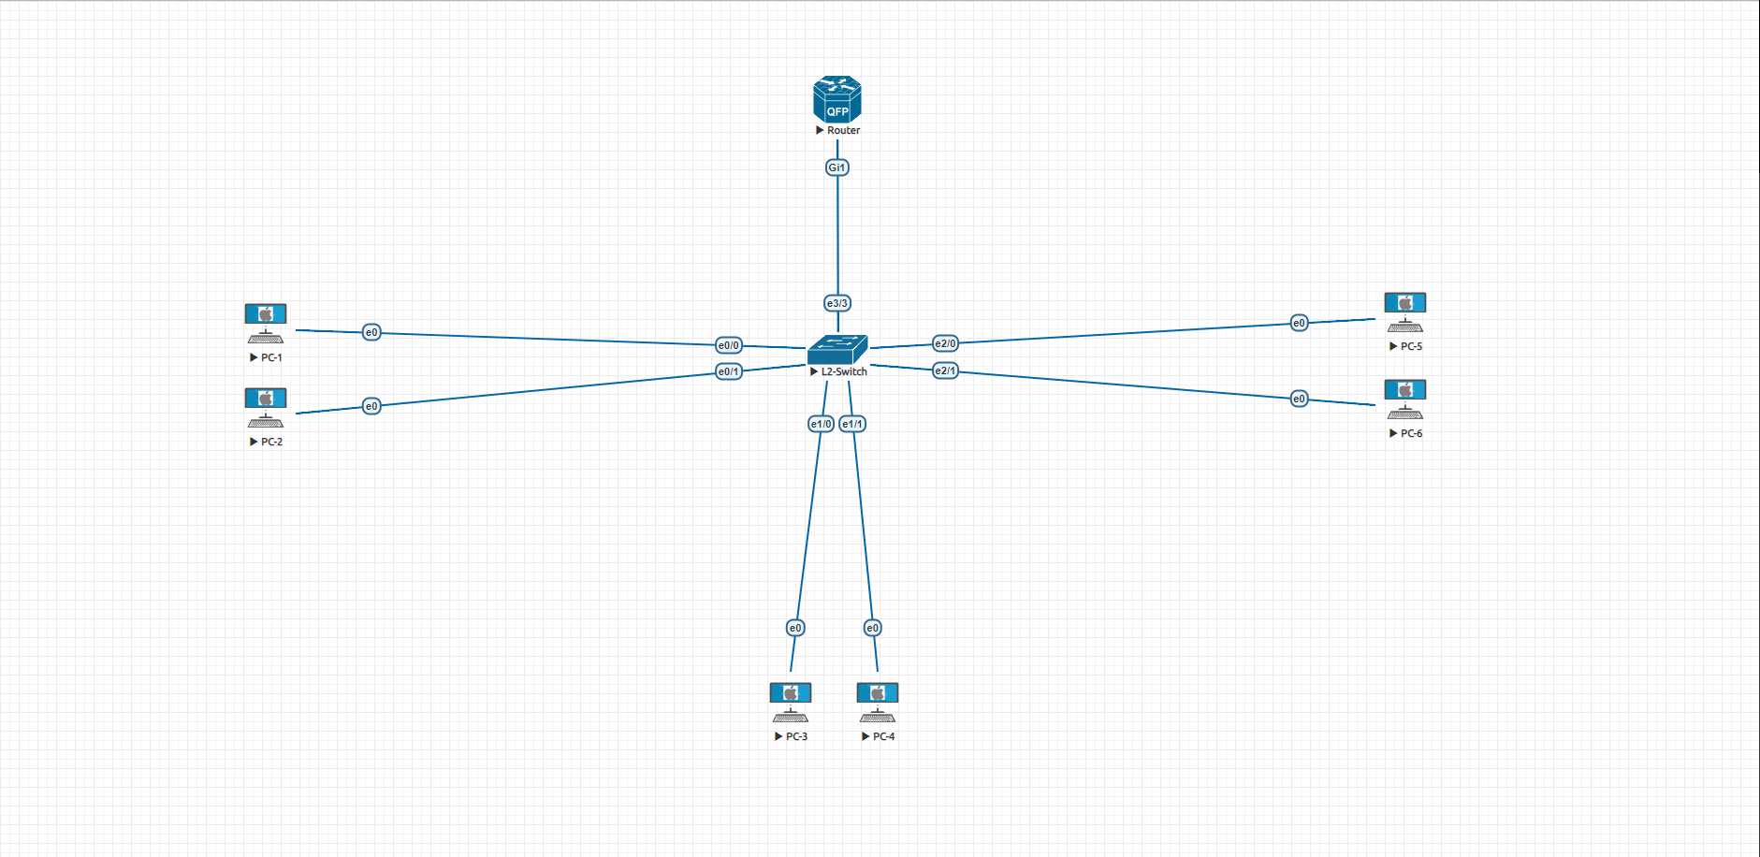

The Evil DHCP is optional.

